Practice Exercise

This document provides a list of exercises to be practiced by learners. Please raise a feedback in Talent Next, should you have any queries.

|  |  |
| --- | --- |
| Skill | RDBMS |
| Document Type | Lab Practice Exercises |
| Author | L & D |
| Current Version | 1.0 |
| Current Version Date | 17-June-2021 |
| Status | Active |

Document Control

|  |  |  |  |
| --- | --- | --- | --- |
| Version | Change Date | Change Description | Changed By |
| 1.0 | 17-June-2021 | Added Problems on Normalization: Finding Attributes and Data Values and Identifying Repeating and Non-Repeating Groups and Converting the Table into Different Normal Forms. | Manpreet Singh Bindra |

Contents

Practice Exercise 1

Document Control 2

Problem Statement 1: Normalization: Finding Attributes and Data Values and Identifying Repeating and Non-Repeating Groups. 4

Problem Statement 2: Create the tables in First Normal Form 1NF by removing the repeating groups. 5

Problem Statement 3: Create the tables in Second Normal Form 2NF and remove the partial dependency. 6

Problem Statement 4: Create the tables in Third Normal Form 3NF and remove the transitive dependency. 7

Problem Statement 5: Draw the ER model for the above relation. 8

Problem Statement 6: Identify the Degree of Relationships and Cardinality of all identified relationships. 9

Note: Every Problem Statement start in a new page

Problem Statement 1: Normalization: Finding Attributes and Data Values and Identifying Repeating and Non-Repeating Groups.

Consider the un-normalized data presented in the below table having the following entity:

* **Employee**

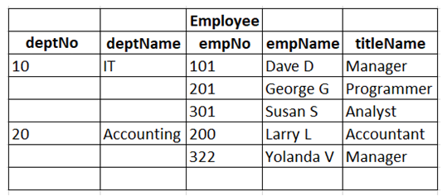

1. Enlist all the entities, attributes, and data types.
2. Identify the candidate key, primary key and foreign keys for the above table.
3. Solve the below sub-problems with respect to the given table:
   1. Inspect the above un-normalized Employee table, what do we notice about the attributes and the data values?
   2. Identify the non-repeating group (Group in which there is only one row in the given scenario).
   3. Identify the repeating group (Group in which there are more than one row in the given scenario)

Problem Statement 2: Create the tables in First Normal Form 1NF by removing the repeating groups.

This is a continuation of the previous problem statement, solve the below sub-problems with respect to problem statement 1:

1. Identify and create the tables in First Normal Form 1NF by removing the repeating groups.
2. Identify the attributes in the tables.
3. Identify the candidate key, primary key and foreign keys for the above tables.

Problem Statement 3: Create the tables in Second Normal Form 2NF and remove the partial dependency.

This is a continuation of the previous problem statement, solve the below sub-problems with respect to problem statement 2:

1. Identify and create the tables in Second Normal Form 2NF by removing the partial dependency.
2. Identify the attributes in the tables.
3. Identify the candidate key, primary key and foreign keys for the above table.

Problem Statement 4: Create the tables in Third Normal Form 3NF and remove the transitive dependency.

This is a continuation of the previous problem statement, solve the below sub-problems with respect to problem statement 3:

1. Identify and create the tables in Third Normal Form 3NF by removing the transitive dependency.
2. Identify the attributes in the tables.
3. Identify the candidate key, primary key and foreign keys for the above table.

Problem Statement 5: Draw the ER model for the above relation.

This is a continuation of the previous problem statement, solve the below sub-problems with respect to problem statement 4:

1. Identify the Entities
2. Identify the Relationships between Entities
   * One to One
   * One to Many
   * Many to Many
3. Identify the key attributes
4. Draw The ER-Diagram

Problem Statement 6: Identify the Degree of Relationships and Cardinality of all identified relationships.

Consider the ER-Diagram prepared in problem statement 5 pertaining to Retail application scenario and answer the questions below:

1. How many entities are present? Name those entities.
2. How many relationships are present? Name those relationships.
3. Mention the degree of all identified relationships.
4. Cardinality of all identified relationships.